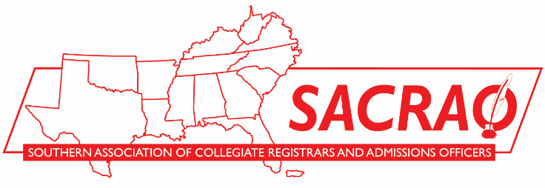

Dear________________:
I am requesting approval to attend the Southern Association of College Registrars and Admissions Officers conference in Little Rock, Arkansas, February 6-9. Attendance at SACRAO is a good investment for our school and for our department.
The SACRAO Annual Conference typically has 400-500 participants from hundreds of higher education institutions across the southeast. SACRAO’s size allows for access to a wealth of knowledge, gives opportunities for plenty of networking, and keeps conference costs reasonable.
Below are a few examples of the resources I will have access to at the SACRAO conference:
- Sessions, forums, and workshops which deal with leading topics in higher education (see SACRAO.org for a program list). The program for the next conference is typically available in mid-December.
- Educational sessions and booths from corporate partners that support higher education.
- Networking events organized to bring professionals with similar concerns together, such as the registrars forum, admissions forum, and user groups of various student information systems.
My top three priorities to accomplish at the SACRAO conference are:
1.
2.
3.
Here is an estimate of the cost to send me to the SACRAO conference
Airfare: $________
Transportation: $________
Hotel: $_______
Meals: $________
Conference Fee: $________ (includes any added workshops on Sunday)
Total: $ ________

I am requesting approval from you now so that I may take advantage of SACRAO’s early-bird registration rate.
I would love to meet with you after the conference to discuss significant takeaways, tips and recommended actions to maximize the efficiency of our department. I will also share these resources with others in the office.
Thank you for considering my request.

Sincerely,

